**IS 340 – Operating Systems**

**HP08 – BASH – Shell Functions**

7/16/2019 Developed by Kevin Wang

6/18/2020 Reviewed by Kim Nguyen

Center for Information Assurance (CIAE) @City University of Seattle (CityU)

  

**Before You Start**

* This exercise assumes that the user is working with the Ubuntu 18.04 distribution. If you are working with a different Linux distribution, the set of shell commands may vary from those available in Ubuntu 18.04.
* Students will use the EC2 Ubuntu virtual machine that they created in the module 1 exercise.
* All commands and code discussed in this exercise will run in the Ubuntu console.
* The directory path shown in screenshots may be different from yours.
* Some steps are not explained in the tutorial**.** If you are not sure what to do:
  1. Consult the resources listed below and experiment in the Ubuntu console and try to solve the problem yourself.
  2. If you cannot solve the problem after a few tries, ask a TA for help.

**Learning Outcomes**

Students will be able to:

* Define functions in the shell
* Define functions in the file
* Use functions in the file

**Resources**

# Linux command line: bash + utilities

<https://ss64.com/bash/>

* Nano/Basics Guide

<https://wiki.gentoo.org/wiki/Nano/Basics_Guide>

**Preparation**

1. Connect to your Ubuntu instance

Open a command prompt

Syntax: ssh -i LOCATION_OF_YOUR_KEY ubuntu@PUBLIC_DNS

Example:

>>>ssh -i key.pem ubuntu@ec2-33-222-101-222.us-west-2.compute.amazonaws.com

1. git pull https://github.com/cityuseattle/IS340-Fall-2020-Assignment.git (to get the most updated content from source repository). If you are prompted to type a message, you can skip this by typing :wq + Enter **!!! NOTE: FOR EACH WEEK, YOU NEED TO DO THIS STEP BEFORE YOU START CODING)!!!**
2. Change directory to the corresponding folder of each week. For example: Your work for module 1 should be stored under Module 1 folder; your work for module 2 should be stored under Module 2, and so on:

* cd “Module 8”

1. Now, follow the instructions provided in each folder to complete your Hands-on Practice

**Define a function in the shell**

1. The bash supports three different syntaxes for defining a function:

* function name <compound command>
* name() <compound command>
* function name() <compound command>

In this module, we will use the second syntax.

1. Define a function in the shell by typing the following command:

>>> circleArea() ( area=`echo "3.1415926 * $1 * $1" | bc -l`; printf "The circle's area is %s\n" "$area" )

Note: the script uses the bc command to calculate float numbers. The syntax is variable=`echo “formula” | bc -l`

1. Test the script by typing the following commands:

>>> circleArea 12



1. You can save the print result to a variable for future usage. Try it by typing the following commands:

>>> info=$( circleArea 5 )

>>> echo $info



Note: you can use this method to get a return value from a function

1. The function also can return an exit code (0 - 255). Test it by typing the following commands:

>>> getNumber() ( return $(( $RANDOM * 255 + 1 )) )

>>> getNumber

>>> echo $?

>>> getNumber

>>> echo $?

>>> getNumber

>>> echo $?

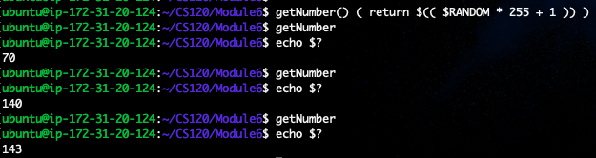

Note: The $? represents the last exit code which we returned from the function. You are supposed to see different numbers since our function returns a random number every time it is executed.

**Define a function in the file**

1. Functions defined in the shell will lose after you close the shell. It is good to write your functions in the file for the reusability
2. Create a script file by typing the following command:

>>> nano SystemSnapshot.sh

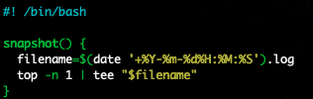

Note: we define a function called snapshot to take a system snapshot by running top command and save the information to a file with the name contains date and time that snapshot was taken.

1. Hit the control + x key to quit and save the file.
2. Before we can use the function that defines in a file, we have to source in the file in the current shell, making functions available to the shell. Run the following command to source in the file:

>>> . SystemSnapshot.sh

1. Try to run the function by typing the following command:

>>> snapshot

>>> clear

We run clear to clear the screen in order to see the file content later.

1. Run the following command to see file names in the folder:

>>> ls



You will see a different file name because it was generated by the date and time you run the function.

1. Check the file content by typing the following command:

>>> cat 2019-07-1802:16:22.log

Note: you should change the file name to your own file name.

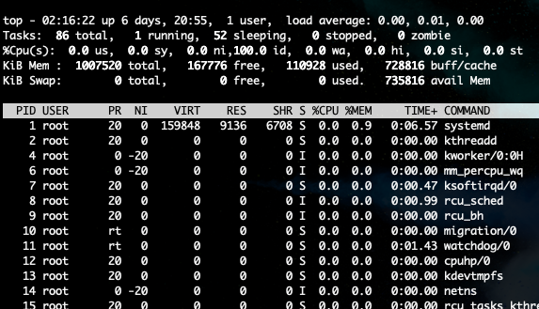

**Push your work to GitHub**

Run the following commands to push your work to the GitHub repository:

>>> git add .

>>> git commit -m “Submission for Module 8 - **YourName**”

>>> git push origin master